Design of an Alpha-Numeric Text Editor with
PC communication
by Perini Alpár

Project context: VGA display control, Keyboard control, Text Editor, Data
Transfer
Submission date: September 27, 2006
Project supervisor: Mircea Dabacan
Technical University of Cluj-Napoca, Faculty of Computer Science

Table of contents:

- Introduction……………………………………………………………………2
- Background……………………………………………………………………2
- Design…………………………………………………………………………5
- Discussion……………………………………………………………………14
- References…………………………………………………………………....17

1. Introduction

We discussed at the University about the possibility of implementing a Text Editor on a Pegasus board. This captured my attention and motivated me for doing this project.

This report presents the design of an alpha-numeric text editor, which is capable of reading and writing a text file (at least a portion of it) from a PC with the help of an application program. The design objectives were met. It is a fully functional text editor that offers only the very basic editing tools. It doesn’t provide features like Shift, Tab and Caps Lock keys and only capital letters are supported. However it provides additional features. The font color can be changed from the switches. A special switch can be used to enter data transfer mode for text. The keyboard is used as another input for the editor. It interprets the Enter, Back Space, Home, End and Arrow keys. The VGA controller meets the signal timings for a resolution of 640x480 pixels at a refresh rate of 60Hz. A Video RAM is used for displaying the text. It uses a special character encoding. A character map ROM is used to convert the character to pixels in order to be displayed on the screen. Another ROM implements the conversion from keyboard Scan Codes to the applied character encoding. The USB communication is implemented according to the Digilent Parallel Interface Model. Two special addresses are used for reading and writing characters into the RAM.

The physical part of the project is written in VHDL and it targets a Xilinx Spartan-3 FPGA. As additional hardware it requires a switch module, a PS2 keyboard and a VGA compatible color monitor. The software part is written in Microsoft Visual C++ using the MFC and the Adept SDK. Since all source files related to hardware implementation are in VHDL, they can be generally used in any design that requires a Keyboard controller, a VGA controller or a DPIM controller. The design as a whole can be reused to develop text editors with more features or with different font styles or at different resolution and refresh rate. The application program can reused to transfer text files to any other board that has a running DPIM controller on it simply by changing the character coding functions that implement the conversion.

The project was developed on a Windows XP computer using the Xilinx WebPack 8.1 ISE CAD tool and the Microsoft Visual C++ 6.0 software developer tool.

2. Background

I didn’t find existing designs for a text editor as a whole but it wasn’t my intention either. However I did reuse two VHDL components: one for controlling the keyboard and one for the display.
The design isn’t hardware dependent: it can work with PS2 keyboards and CRT displays from any manufacturers. Regarding the PC there is the constraint that the application program used to transfer text files runs only on Windows platforms.

2.1. CRT display controller
CRT-based VGA displays use amplitude modulated, moving electron beams (or cathode
rays) to display information on a phosphorcoated screen.
Information is only displayed when the beam is moving in the “forward” direction (left to right and top to bottom), and not during the time the beam is reset back to the left or top edge of the display. Much of the potential display time is therefore lost in “blanking” periods when the beam is reset and stabilized to begin a new horizontal or vertical display pass.
The size of the beams, the frequency at which the beam can be traced across the display, and the frequency at which the electron beam can be modulated determine the display resolution. The controller must produce synchronizing pulses at 3.3V (or 5V) to set the frequency at which current flows through the deflection coils, and it must ensure that video data is applied to the electron guns at the correct time.
Video data typically comes from a video refresh memory, with one or more bytes assigned to each pixel location. The controller must index into video memory as the beams move across the display, and retrieve and apply video data to the display at precisely the time the electron beam is moving across a given pixel.
A VGA controller circuit must generate the HS and VS timings signals and coordinate the delivery of video data based on the pixel clock. The pixel clock defines the time available to display 1 pixel of information. The VS signal defines the “refresh” frequency of the display, or the frequency at which all information on the display is redrawn.
The number of lines to be displayed at a given refresh frequency defines the horizontal “retrace” frequency. For a 640- pixel by 480-row display using a 25MHz pixel clock and 60 +/-1Hz refresh, the signal timings shown in the table below can be derived.
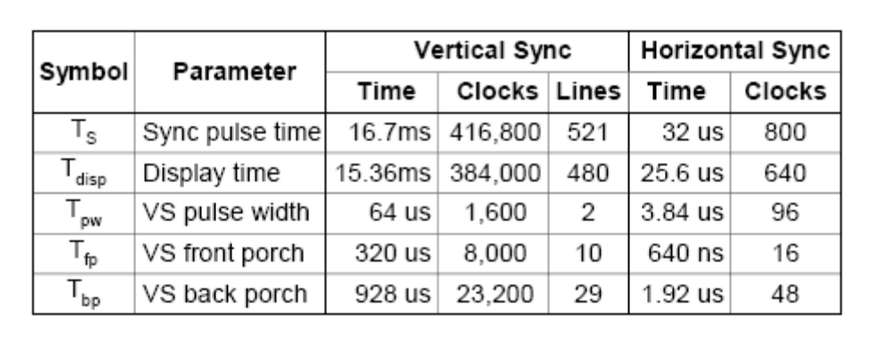
Timings for sync pulse width and front and back porch intervals (porch intervals are the pre- and post-sync pulse times during which information cannot be displayed) are based on observations taken from VGA displays.
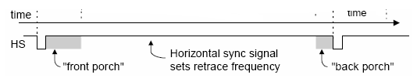
A VGA controller circuit decodes the output of a horizontal-sync counter driven by the pixel clock to generate HS signal timings. This counter can be used to locate any pixel location on a given row. Likewise, the output of a vertical-sync counter that increments with each HS pulse can be used to generate VS signal timings, and this counter can be used to locate any given row.
These two continually running counters can be used to form an address into video RAM. No time relationship between the onset of the HS pulse and the onset of the VS pulse is specified, so the designer can arrange the counters to easily form video RAM addresses, or to minimize decoding logic for sync pulse generation.

2.2. Keyboard controller
The keyboard uses open collector drivers so that either the keyboard or an attached host device can drive the two-wire bus (if the host device will not send data to the keyboard, then the host can use simple input-only ports). PS2-style keyboards use scan codes to communicate key press data (nearly all keyboards in use today are PS2 style).
Each key has a single, unique scan code that is sent whenever the corresponding key is pressed. If the key is pressed and held, the scan code will be sent repeatedly once every 100ms or so. When a key is released, an “F0” key-up code is sent, followed by the scan code of the released key. If a key can be “shifted” to produce a new character (like a capital letter), then a shift character is sent in addition to the original scan code, and the host device must determine which character to use. Some keys, called extended keys, send an “E0” ahead of the scan code (and they may send more than one scan code). When an extended key is released, an “E0 F0” key-up code is sent, followed by the scan code.
A host device can also send data to the keyboard.
The keyboard should send data to the host only when both the data and clock lines are high (or idle). Since the host is the “bus master”, the keyboard should check to see whether the host is sending data before driving the bus. To facilitate this, the clock line can be used as a “clear to send” signal. If the host pulls the clock line low, the keyboard must not send any data until the clock is released.
The keyboard sends data to the host in 11-bit words that contain a ‘0’ start bit, followed by 8-bits of scan code (LSB first), followed by an odd parity bit and terminated with a ‘1’ stop bit. The keyboard generates 11 clock transitions (at around 20 - 30KHz) when the data is sent, and data is valid on the falling edge of the clock.
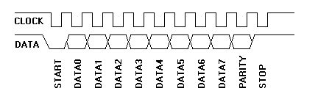
2.3. Digilent Parallel Interface Model
The Digilent Communications Interface DLL, dpcutil.dll, provides a set of API functions for applications programs running on a Microsoft Windows based computer to exchange data with logic implemented in a Digilent system board. Various Digilent applications programs, such as Transport component of the Adept Suite, depend on the data interchange API functions in dpcutil. The operation of these functions depends on the presence of a Digilent communications subsystem component running the appropriate firmware and the implementation of the appropriate interface logic in the gate array. This document describes the functional requirements of the communications interface logic and provides a sample implementation.
The logic described in this document implements are set of registers in the gate array. An application on the host PC exchanges data with the design in the gate array by reading or writing these registers. Digilent Communications Interface modules implement the described interface to control the reading and writing of these registers.

3. Design

The block diagram of the components that were used along with their description is presented below:

  - ALU
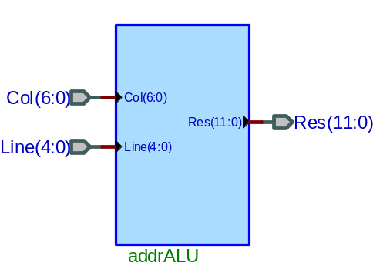

Signal | Mode | Description
Col(6:0) | Synchronous input | Column address of the current character
Line(4:0) | Synchronous input | Line address of the current character
Res(11:0) | Output | Memory address of the character: Col*80+Line  Allows the usage of the whole contiguous memory space

  - Character Map

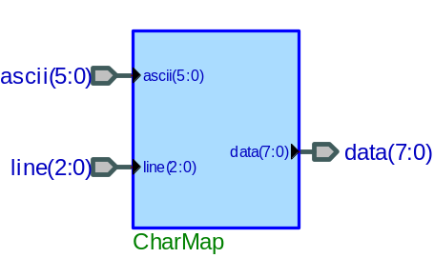

Signal | Mode | Description
Ascii(5:0) | Synchronous input | The predefined code of the actual character
Line(2:0) | Synchronous input | Number of the pixel line from the previously defined character
Data(7:0) | Output | The pixel codes of the character line: ROM(Ascii&Line)  8 bits representing a line from the 8x8 character matrix

3.3. Code Convertor

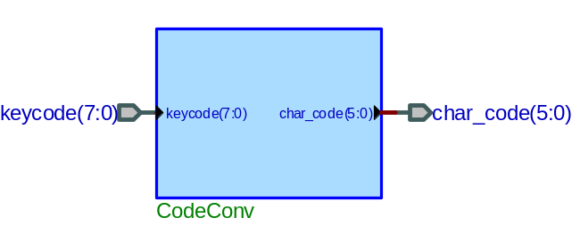

Signal | Mode | Description
KeyCode(7:0) | Synchronous input | Scan code of key received from the keyboard
Char_Code(5:0) | Output | The encoding of the character corresponding to the keyboard scan code: ROM(KeyCode)  This encoding is used in the whole project.

  - MUX 2:1

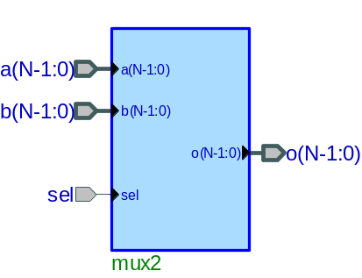
Signal | Mode | Description
A(N-1:0) | Synchronous input | First N bit input
B(N-1:0) | Synchronous input | Second N bit input
Sel | Asynchronous input | Selection signal of the generic MUX 2:1
O(N-1:0) | Output | N bit output corresponding to the selection:  A, when Sel=0  B, otherwise

3.5. Dual Port Block RAM with one read/write port and a read port:

Signal | Mode | Description
addrA(11:0) | Synchronous input | Address line for port A
addrB(11:0) | Synchronous input | Address line for port B
diA(8:0) | Synchronous input | Input data
CLK | Clock input | Cock input for memory
enA | Synchronous input | Enables the memory
weA | Synchronous input | Write enable signal:  RAM(addrA)←diA, when weA=1
doA(8:0) | Output | Output data from port A: doA←RAM(addrA)
doB(8:0) | Output | Output data from port B: doB←RAM(addrB)

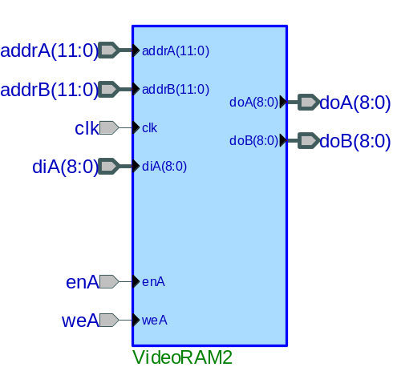

3.6. VGA controller

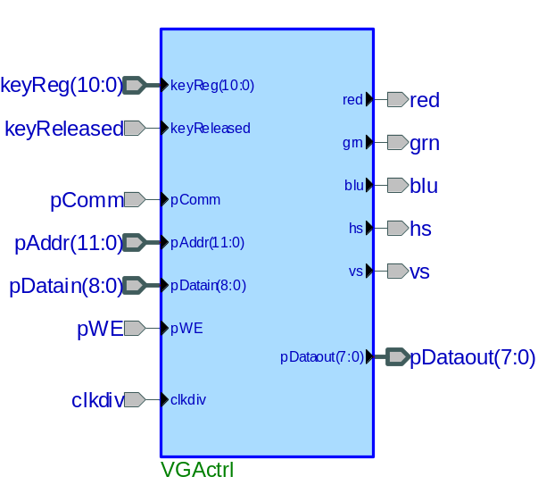
Signal | Mode | Description
keyReg | Synchronous input | Register for the keyboard scan code
keyReleased | Synchronous input | Handshake indicates when a key was released on the keyboard
pComm | Asynchronous input | When 1 activates the EPP communication
pAddr | Synchronous input | Video RAM address from the DPIM
pDataIn | Synchronous input | Video RAM input data from the DPIM
pWE | Synchronous input | Video RAM write enable from the DPIM
Clkdiv | Clock input | Precise 25 MHz clock input
Red | Output | Red signal output for the display
Grn | Output | Green signal output for the display
Blu | Output | Blue signal output for the display
Hs | Output | Horizontal sync output for the display
Vs | Output | Vertical sync output for the display
pDataOut | Output | Video RAM data output for the DPIM

The core of the display consists of the horizontal and vertical counters. They are calibrated such that the visible area starts at 0, so they can be used as indexes later on. The HS and VS signals become active they are in a well defined interval corresponding to the VESA timing of a 640x480 display while assuming that the system clock is a 25MHz oscillator. If the frequency is changed, the counters have to be recalibrated accordingly.
Characters are made of 8x8 pixel patterns stored in a character map ROM and they have a unique code, just like ASCII for DOS. These unique codes are stored in a memory called a Video RAM. The address where they can be found is derived from the current values of the two counters.
The horizontal counter is divided by 8, while the vertical by 16, because every odd line is blank. Then the actual address is computed from these values by an arithmetic unit. The number of lines is multiplied by 80 and the column number is then added to it. This way addresses become continuous and no unused space remains between rows.
The character code is always read from this address. Then this code and the least significant 3 bits of the vertical counter are used as address into the character map ROM. This way we obtain a line of the character’s pixel pattern. From this line the actual pixel value can be found by demultipexing the bits according to the least significant 3 bits of the horizontal counter.
Finally using this pixel and the signal that tells us whether the counters are in the visible area (vidon), the red, green and blue signals can be activated and this way the character will be built up from its pixels.
This approach is needed, because a character can’t be displayed totally at a time , because of the way the counters are functioning. Consequently there is no possibility to go back a line and start displaying the other character and so on.
Up to this point was the simple display itself. Now we can add different functionalities like selecting the character’s color from the switches. This is done simply by storing three more bits in the video RAM for the color.
A more difficult task is to make it possible to edit certain characters in the RAM. This is done by using a prompt (cursor). A new character is edited or deleted at the address corresponding to the cursor’s address. The cursor address is stored as two registers (FFs): one for the line and one for the column address. Then later the content of these registers can be modified according to the nature of the character that was received. Due to the fact that a dual port RAM is used, scan codes can be received even when the unit is displaying characters. Then these codes are converted to the “ASCII-like” coding used here with the help of a Code Converter ROM and can be input to the RAM along with the color switches. At this time the write enable signal for the RAM has to be active as well, but only for this time, otherwise it will modify other characters as well. For this purpose a clock-type signal has to be generated from the keyReleased signal.
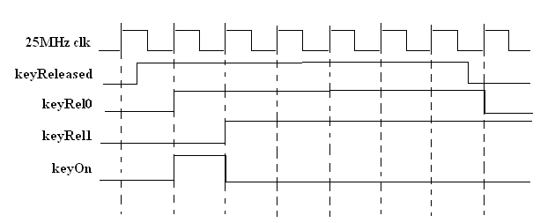
This is done by using two FFs and some basic logic gates.
Now we add two multiplexers before the address computation logic with the pComm selection and the RAM becomes editable by the communication module through the handshaking signals. The write enable and the address signals are multiplexed along with the keyboard signals. When the communication is on, no characters can be received from the keyboard, in spite of the fact that cursor can move. This way the video RAM can be written as well as read from the exterior.

3.7. Keyboard controller

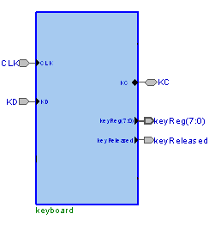

Signal | Mode | Description
KD | Asynchronous input | Keyboard data signal input
KC | Asynchronous input | Keyboard clock signal I/O
CLK | Clock input | Precise 25MHz clock input
RST | Asynchronous master reset | Master reset
AN | Output | Enables the seven-segment anodes
SSEG | Output | Drives a seven-segment’s display leds
keyReg | Output | Scan code of the last key that was pressed
keyReleased | Output | Handshake signal indicating that a key was released on the keyboard

The clock input is divided down to a lower frequency similar to the keyboard’s operating frequency. At this rate the KD and KC signals are sampled and the data received is shifted in on the falling clock edge to two shift registers from the left. When the second register contains the ‘F0’ key code, it means that a key was released. This means that the data stored in the first register should be a valid scan-code. It will be prepared for output along with the handshaking signal keyReleased. The scan-code of the key that was pressed could be encoded and displayed on the two seven segment digits.

3.8. Digilent Parallel Interface Model (DPIM)

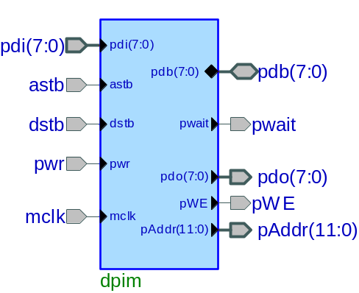

Signal | Mode | Description
pDI(7:0) | Synchronous input | Register for input data that needs sending
ASTB | Asynchronous input | Address strobe. Causes data to be read or written to the address register
DSTB | Asynchronous input | Data strobe. Causes data to be read or written to a data register
pWr | Asynchronous input | Transfer direction control:  High(1)=read, Low(0)=write
Mclk | Clock input | Master clock from the system board oscillator; here 25MHz is used to be in sync with other components
pDB(7:0) | Synchronous input/output | Bidirectional EPP data bus
pWait | Asynchronous input | Synchronization signal indicating when the peripheral is ready to accept data or has data available
pDO(7:0) | Output | Register for output data that was received
pAddr(11:0) | Output | Output address register indicating to what address should the output data be written
pWE | Output | Write enable output to mark the output data to be written (into a RAM)

The Digilent Port Interface is patterned after the EPP mode of the parallel port interface on an IBM PC type computer. This interface provides an 8 bit bi-directional parallel data bus and six handshaking lines to control the data transfer.
The parallel port interface is made up of an eight bit wide address register and a set of eight bit wide data registers. The address register holds the address of the data register currently being accessed. Access to the registers is accomplished via transfer cycles. The four types of transfer cycles allowed are: address read, address write, data read, and data write.
The direction of the data transfer is controlled by the WRITE signal. If WRITE is high (indicating a READ cycle) the peripheral is the source of the data and drives its data onto the bidirectional data bus at the appropriate time in the cycle. If WRITE is low (indicating a WRITE cycle) the host is the source of the data and drives its data onto the bidirectional data bus. It is extremely important that the peripheral logic in the gate array not drive data onto the data bus except during a READ cycle.
All bus cycles are initiated and controlled by the host.
The WAIT signal is used to synchronize transfers between the host and the peripheral. The host will not begin a transfer unless the wait signal is low. Once the host begins a bus cycle, it will hold the strobe (either ASTB or DSTB) in the active state (prolonging the bus cycle) until WAIT goes high.
WAIT going high signals that the peripheral has completed its processing of the cycle. The host will then bring the strobe to the inactive state completing the bus cycle. The peripheral then brings WAIT low when it is ready for another transfer to begin.
If WAIT is not brought high within approximately 10ms of the start of a transfer, the communications module will abort the transfer and report a time out error back to the host. Similarly if WAIT does not come low to allow a transfer to begin within approximately 10ms, the communications module will report a time out error to the host.

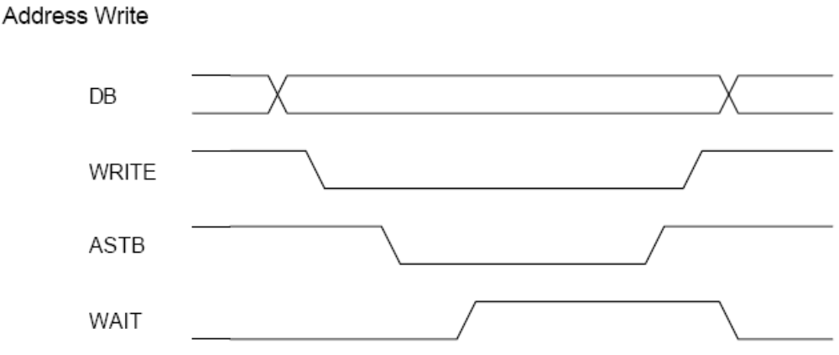

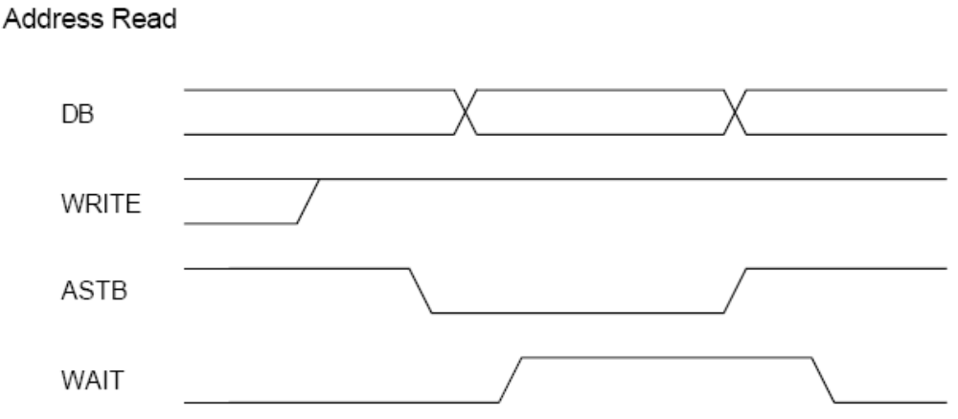
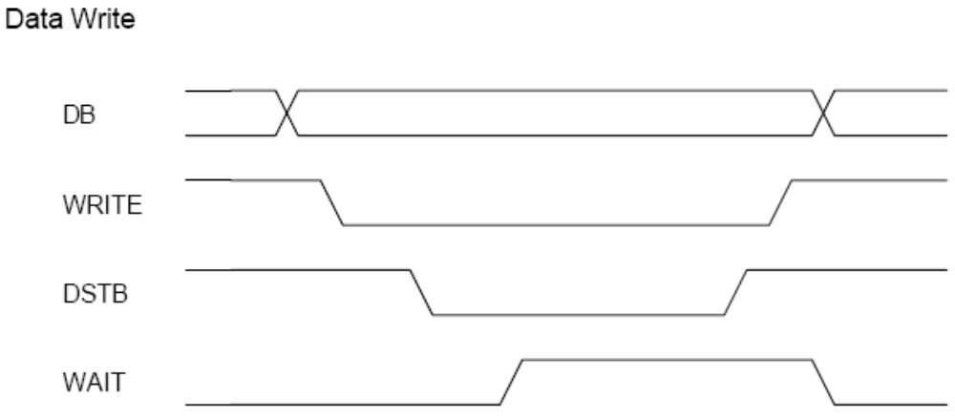

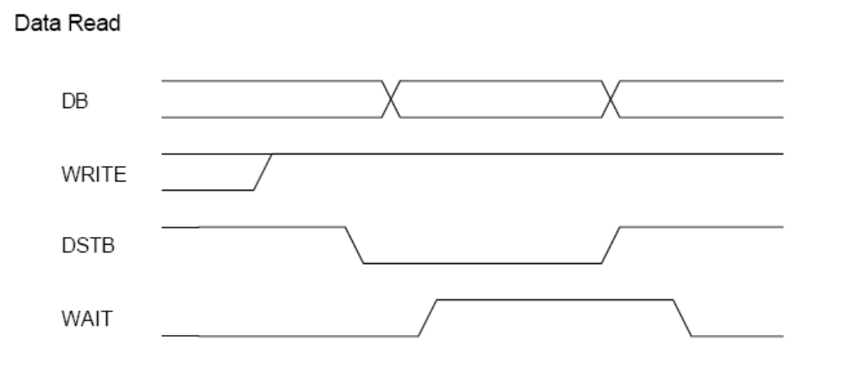

3.9. VGA Editor Main block

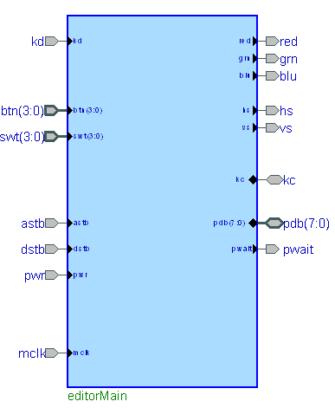

Signal | Mode | Description
KD | Asynchronous input | Keyboard data signal
KC | Asynchronous input | Keyboard clock signal
SWT(3:0) | Asynchronous input | 4 switches on the system board
ASTB | Asynchronous input | EPP address strobe
DSTB | Asynchronous input | EPP data strobe
pWr | Asynchronous input | EPP transfer direction control
mClk | Clock input | 25 MHz master clock input from the system board oscillator
Red | Output | Red signal output for the display
Grn | Output | Red signal output for the display
Blu | Output | Red signal output for the display
Hs | Output | Red signal output for the display
Vs | Output | Red signal output for the display
pDB | Input/Output | Bidirectional EPP data bus
pWait | Output | EPP synchronization signal

The three main modules will be interconnected according to the schematic below. Unfortunately they have to be implemented as a whole because only this way did the Xilinx Web Pack tool produce a design where all the components were functioning as expected and were stable.

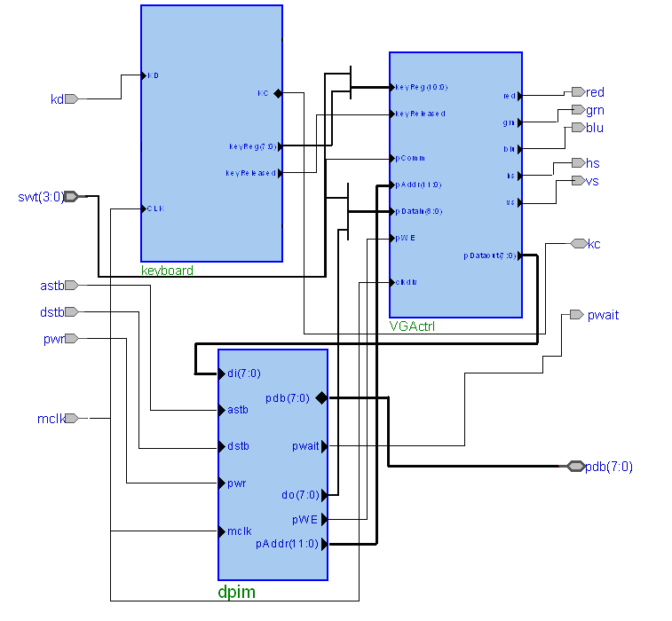

Switch 0 will turn on or off the communication logic. Switches 1, 2 and 3 will be used to select the font color as RGB format. It is very important to have the system clock oscillator at 25MHz because most of the components were designed for this frequency. Therefore if a higher frequency is connected, it has to be divided down to obtain the desired working frequency. Otherwise the display can suffer damage if it is not protected.

4. Discussion

It was quite a complex design. Some problems were encountered but they were solved. They were related to using the Video RAM to display characters, the interconnecting of the display with the keyboard and with the communication module and as well as some particularities of the Spartan3 chip.

When I first started this project, I had a DIO4+D2SB package. This had a Sparta2E board with a 50MHz oscillator. The very first problem was that the display timing wasn’t set up properly. The retrace phenomenon could be seen on the screen. Then I managed to solve this problem by recalculating all values such that the counters’ zero value corresponded to the beginning of the visible area. The next problem was that the characters weren’t displayed properly. After looking at the display for some time, I observed that the characters were mirrored vertically. This was because of the way the character map was designed (the elements were ‘std_logic_vectors’ with ‘downto’ range). It was corrected by doing the multiplexing the complementary way. Then the characters were better, but they had a small portion missing. I tried a lot of things, inclusively changing the RAM style, which by that time was a single port block RAM). It didn’t have any effect.
Then I tried adding the keyboard module to my design. Here the first problem was that the key that was pressed was displayed on the whole screen. Here the write enable signal of the RAM had to remain active for only a single clock period and this was also used for selecting the correct input for the display. Both the keyboard and the display couldn’t use the RAM the same time. When this was corrected, the mistake was that the char appeared at the new position of the cursor, not where it was before the key was pressed. This was solved by introducing one clock delay and using this to condition the new cursor (prompt) position. Then the special keys had to be introduced. The backspace caused a little trouble, because it required the write enable to be active when the position to the left was reached. This was corrected by decrementing the RAM address, whenever the backspace was detected. Then I remarked that all the characters that were entered using the keyboard were displayed correctly. Only those that were initially introduced into the RAM had errors. This happened with the Xilinx 7 tools, but when I tried it with Xilinx 8 later, everything displayed correctly, so probably the initial content wasn’t interpreted correctly.
The next phase in the project was when I received the new Nexys board with Spartan3 chip. I changed the device parameters accordingly, but the keyboard wasn’t working. On the other hand this time the initial content of the RAM was displayed correctly. I tried the same project with Xilinx 8, but still without luck. Then I made some changes that mainly affected the address computation, which was now made more efficient and making more synchronous elements. Also all components were made to function at the same clock frequency, which was now set to 25MHz, and there was no need to divide down the 50MHz. Now the keyboard started to function. Then I wanted to introduce the EPP communication module provided by Digilent. I first tried it separately, and it was working perfectly. When I added it to the design, neither did the display, nor did the keyboard work. In the new Xilinx, only the keyboard didn’t work. I tried to find the cause by examining all the warning and info messages that the Xilinx tool gave. I tried to fix them, but then I found one that I didn’t know what it meant. It said that the tri-states couldn’t be replaced by combinatorial logic. I read after this error on the Xilinx web site and found that this was an error related to Spartan3 FPGA and it was because it didn’t have internal tri-states. There four solutions were presented. I found that one could be potentially related to my problem. It said that it couldn’t be synthesized correctly, because the tri-state signal is in the main module and it is used as input to a black box, which in my case I assumed it is the Digilent communications module. I didn’t see any alternative but to remove the component and add it as it is to my main module. This way the design was working. I made the necessary changes to allow the connection to the RAM. This time it had keyboard problems again. There were many warning related to excessive skew of some clock-type signals. I supposed that this could be the reason of the malfunction. I read the warning at it said that it should be corrected by using buffer resources. In the XST user guide I found the ‘clock_signal’ and ‘buffer_type’ attributes. I used these on some of these signals and the keyboard started to function. But this time the problem was that the keys were working but the cursor wasn’t moving from its initial position. I couldn’t really understand how this was possible, since before it was working perfectly. I tried to change some synthesize as well as implementation options and I even rewrote to part that was moving the cursor. Finally I arrived at a working design.
The problem was that when I recompiled the same design a few days later, it had problems again. The cursor was staying at its initial place. I lost my rationality, thinking that there are some problems with my Xilinx. I started to change some synthesize and map options again. I set the ‘Preserve hierarchy on sub-module’ option and found among the warnings that the two signals that connected the keyboard with the display can’t satisfy this option. Then I decided to build a new project and include all the three main components to a single main module. I also decided to change the single port block RAM to a dual-port block RAM in order to reduce the degree of multiplexing needed. I made these changes and found that all modules were working now. But when I added the possibility of scrolling up and down, the data transfer from the PC to the board wasn’t perfect. Some characters appeared more times as they should. I modified some FFs that were working on the rising edge of some signals that were generated by combinatorial logic to work on the main clock and use these signals as clock enables. I also made some changes in the synthesize options and finally the design was working properly.

The design is implemented on a Digilent Nexys board having a Spartan3 FPGA. The design works at a 25Mhz operating frequency, but if the dividing factors are carefully changed it can work at different frequencies.

The project created in the Project Navigator has to be properly set up in order to function correctly:
- In the Project Properties menu, set the Family to Spartan3, the Device to xc3s200, the Package to FT256 and finally the Speed to -4.
- In the Synthesis menu under Synthesis Options set the FSM encoding to None and disable Resource sharing while under Xilinx Specific Options turn on Register Balancing if an increased clock frequency is desired.
- In the Implement design menu under Map Properties set the Optimization Strategy to Speed.
- In the Generate Programming File menu under Startup options set the FPGA start-up clock to JTAG clock.

Only a few simple components could be tested separately. Most of them required to be implemented on the board and needed also keyboard and display because the corresponding signal timings had to be met.

Device Utilization Summary
Logic Utilization | Used | Available | Utilization | Note(s)
Number of Slice Flip Flops | 191 | 3,840 | 4%
Number of 4 input LUTs | 754 | 3,840 | 19%
Logic Distribution
Number of occupied Slices | 441 | 1,920 | 22%
Number of Slices containing only related logic | 441 | 441 | 100%
Number of Slices containing unrelated logic | 0 | 441 | 0%
Total Number 4 input LUTs | 770 | 3,840 | 20%
Number used as logic | 754
Number used as a route-thru | 12
Number used as Shift registers | 4
Number of bonded IOBs | 24 | 173 | 13%
IOB Flip Flops | 11
Number of Block RAMs | 3 | 12 | 25%
Number of GCLKs | 2 | 8 | 25%
Total equivalent gate count for design | 203,544
Additional JTAG gate count for IOBs | 1,152

Timing Summary:

Speed Grade: -4
Minimum period: 14.229ns (Maximum Frequency: 70.279MHz)
Minimum input arrival time before clock: 6.610ns
Maximum output required time after clock: 26.255ns
Maximum combinational path delay: 11.138ns

The design required about five hours of research, 100 hours of implementation and testing, and half an hour of simulation. A Digilent FPGA board was used to host and test the design. A windows PC was used for CAD tools during the design,

5. References

- Digilent Pegasus Demo containing modules for display and keyboard that could be reused: Pegausdemo.zip
- Character Map ROM for displaying the characters: chmap.doc
- Digilent Parallel Interface Model Reference Design: dpimref.vhd
- Digilent Adept SDK – libraries and demo: AdeptSDKv1-2.exe
- DIO4_rm.pdf – keyboard and display theoretical background
- DpimRef.pdf – DPIM description and functioning

